**1. Creating and Renaming Files/Directories**

* **Create a directory named test_dir using mkdir.**



* **Inside test_dir, create an empty file called example.txt.**

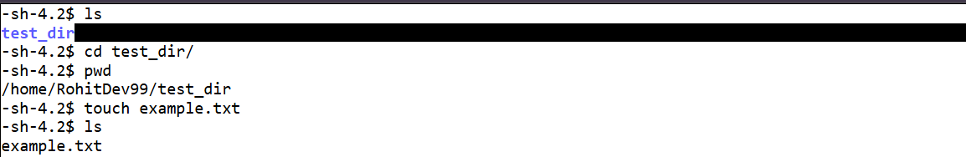

* **Rename example.txt to renamed_example.txt using mv**



*mkdir test_dir → Creates a new directory named test_dir.*

*cd test_dir → Moves into that directory.*

*touch example.txt → Creates an empty file.*

*mv example.txt renamed_example.txt → Renames the file.*